# File permissions in Linux

## Project description

The aim of the project is to showcase the ability to modify, grant or remove permissions on files and subdirectories using the linux command line.

## Check file and directory details

First I changed my directory for the aimed subdirectory: projects

Then I run the ls command showing also hidden files/subdirectories and their permission strings.

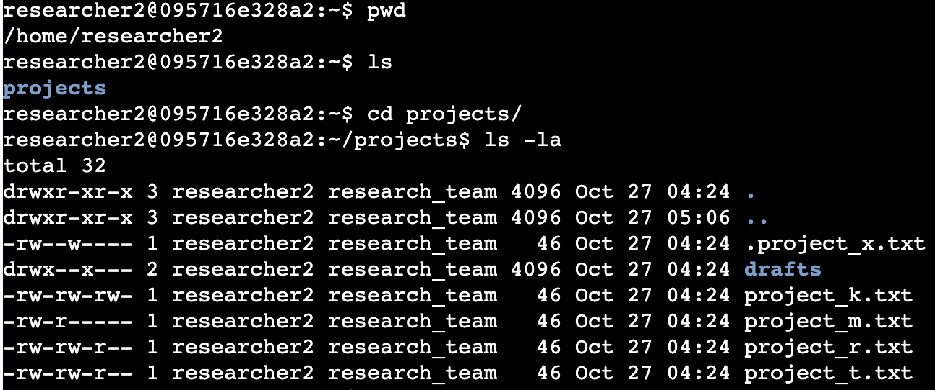

## Describe the permissions string

The permission string is a list of characters that indicate the level of authorization of each of the 3 users (owner user, group and others) respectively. R-read, W-write, X-execute. If the string starts with “-” then it’s a file. If it starts with “d” then it’s a directory (sub-directory).

## Change file permissions

To change permissions on a given file or sub-directory, I used the chmod command. We need to specity on which user group we need to do the permission amendment, then input + or - in order to grant or remove the given type of access. Finally, we need to input the file or sub-directory name where we want these changes to be made.

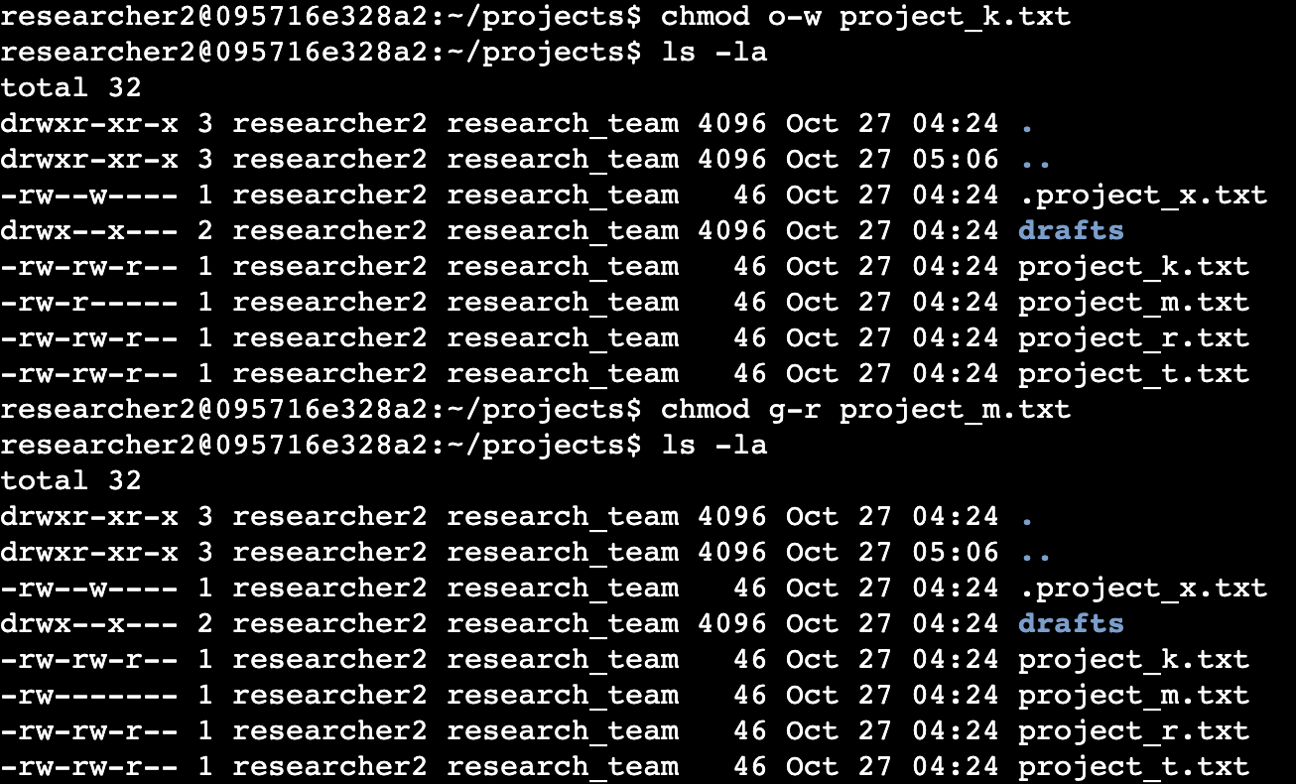

## Change file permissions on a hidden file

The same principle applies to changing permissions on a hidden file. For example, I modified different permissions on the hidden file “.project_x.txt” in order to grant user and group read access only to mentioned file.

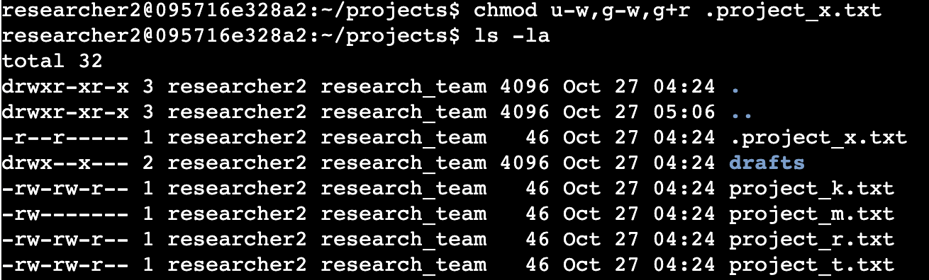

## Change directory permissions

Finally, still using the chmod command, I modified the access of the sub-directory “drafts” to only grant user researcher2: writable, readable and executable priviledges

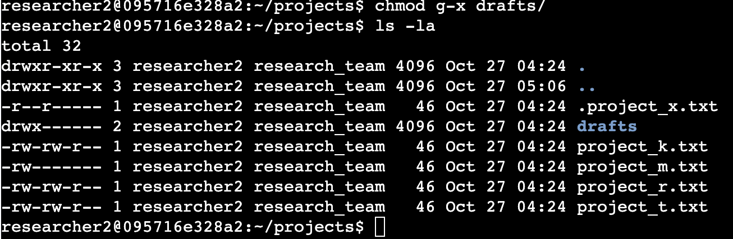

## Summary

Through this project I was able to modify, grant and remove accesses of different files and sub-directories, hidden and visible on different user levels while showcasing my ability to utilize the linux command.